HOW TO REGISTER TEAMS
How to Register Teams for CLS Travel Season (Fall, Winter, Spring) or August Festival.
From the Central League website, click on the appropriate registration link.
Then, click on the link to log into the Demosphere system
You should see this window-
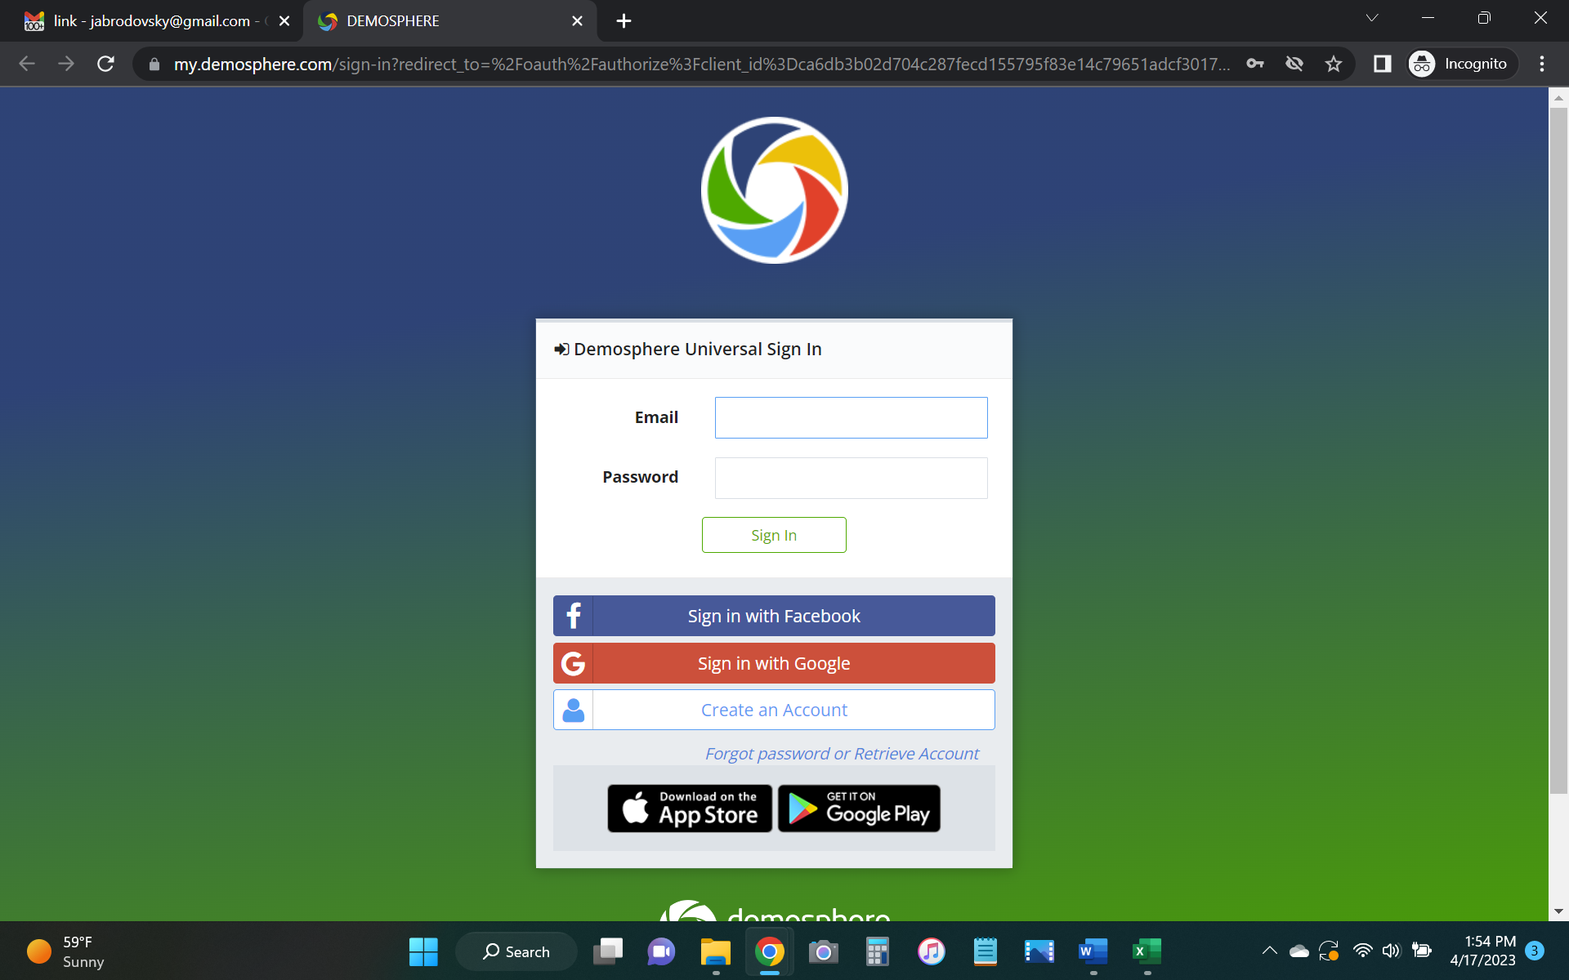
Login with either Facebook, Google, or Create an Account. Once that is complete, you will see the screen below.
The first screen will be this one-
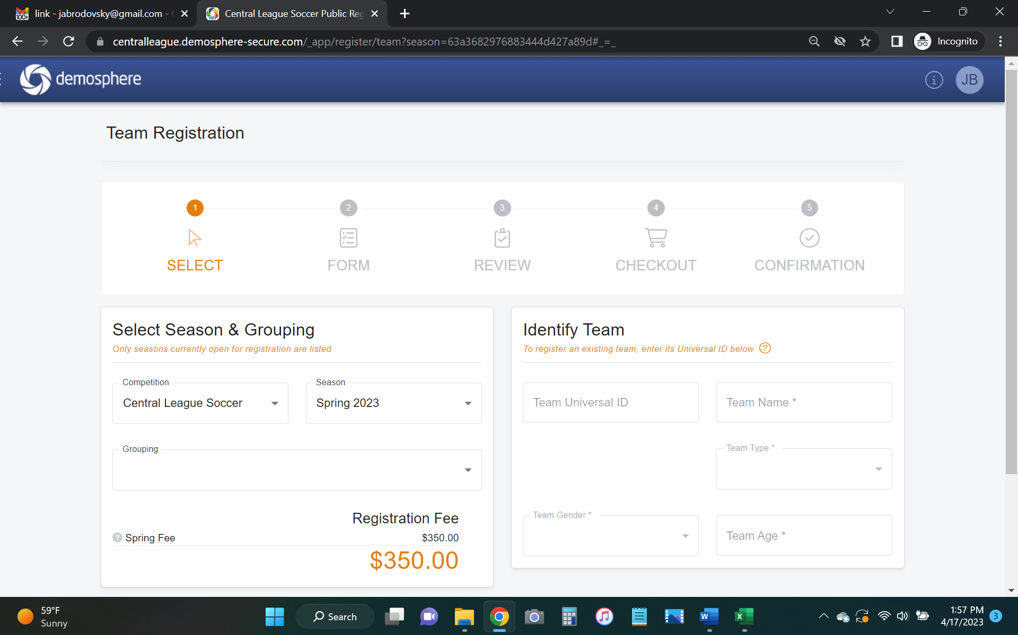
Make sure that the Competition window is set to the value of Central League Soccer and the Season is the correct one.
Select the appropriate Grouping Male>U09 Tier 1, Female> U12 Tier 2, etc. This will automatically populate the Team Type, Team Gender and Team Age fields.
For your initial registration, leave Team Universal ID field blank/empty
Enter the Team Name.
Click Next
On the screen below, please enter the following information:
Enter the Club Name and Team Name, State ID, Team Rank, Head Coach/ Asst Coach/ Team Manager Name & Contact information. When complete, click the Review button.

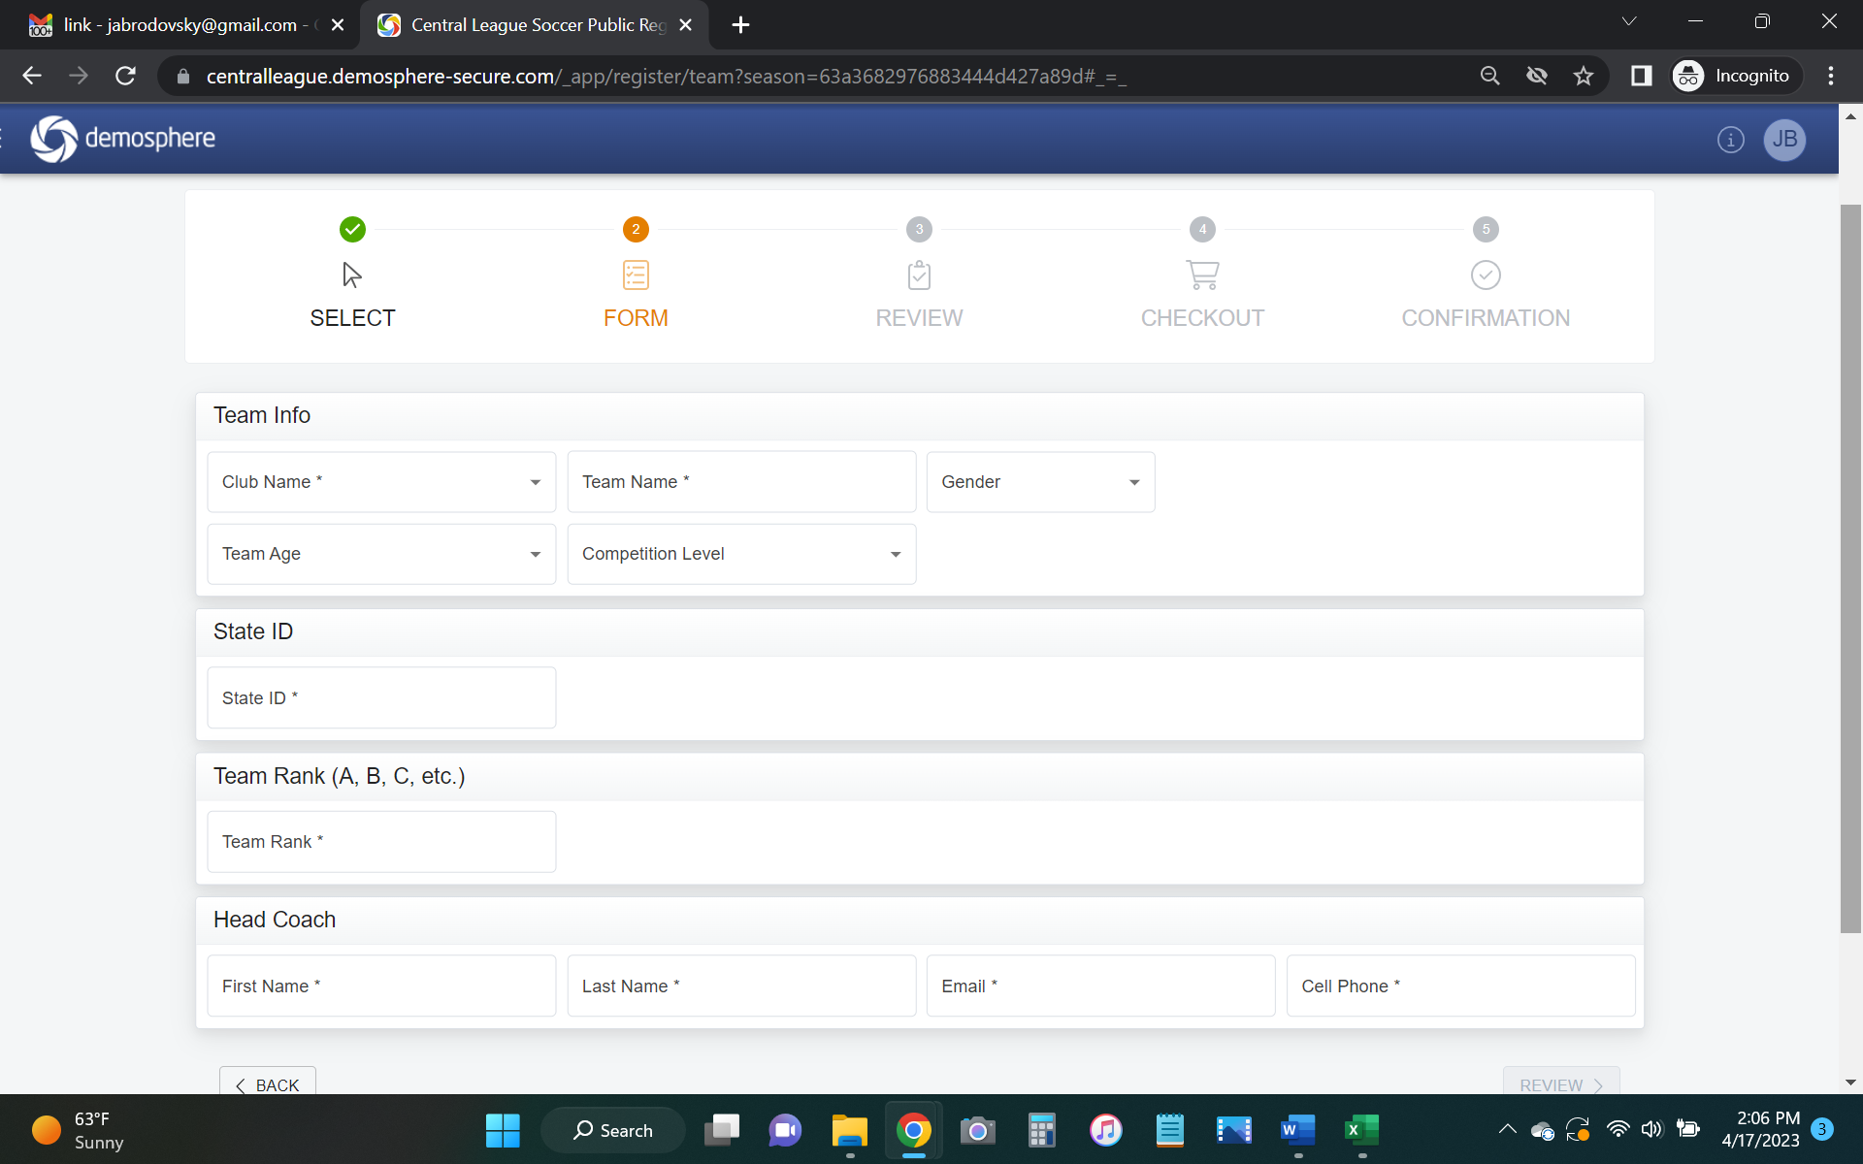

When the window below pops up, be sure to review everything, then click on the Checkout button.
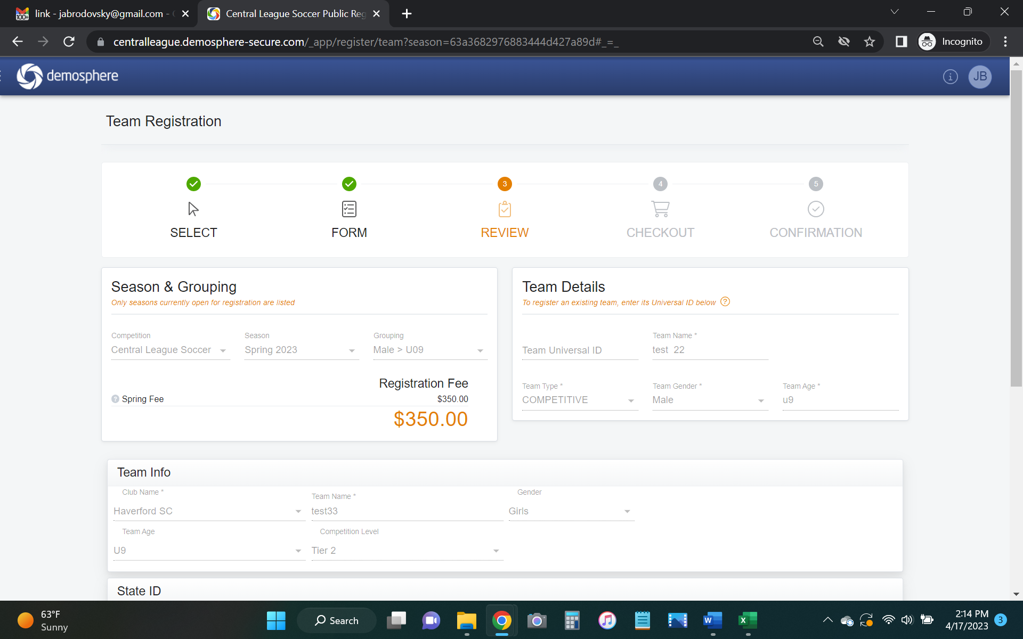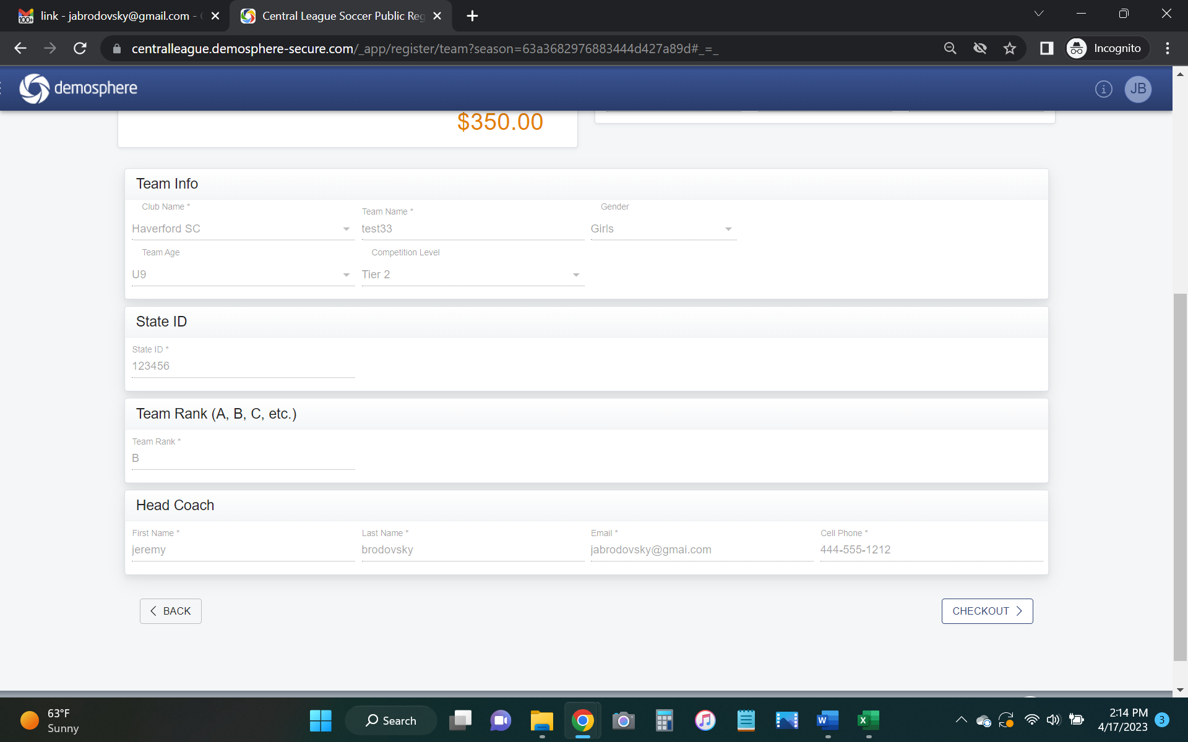

On the next window, select Personal Check under the Payment Method. And select Your Role from the drop down menu under Registrant Info.
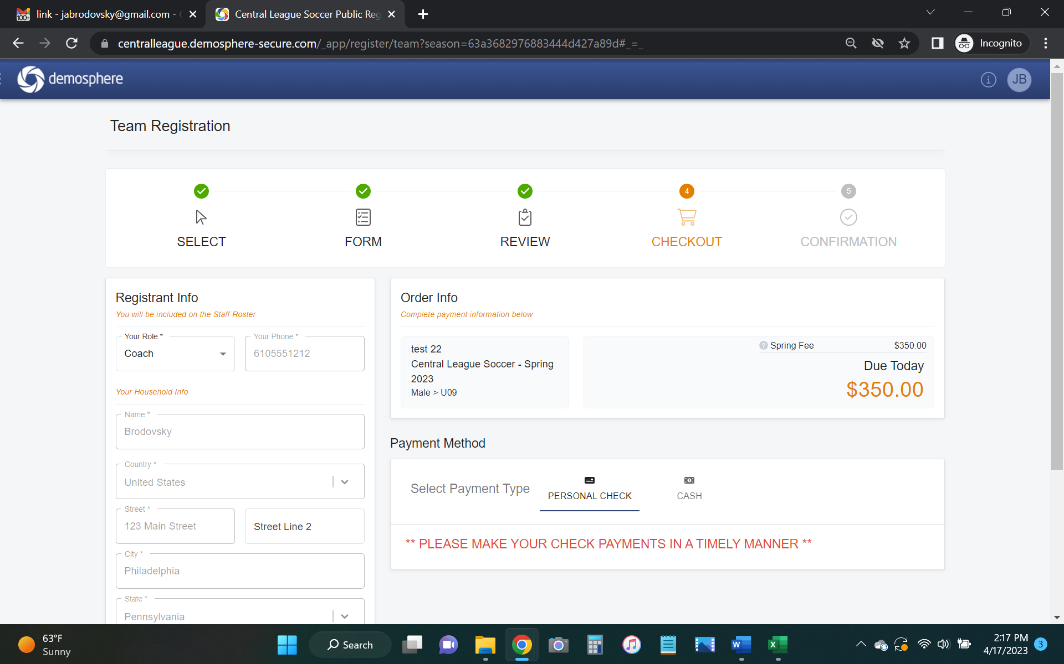
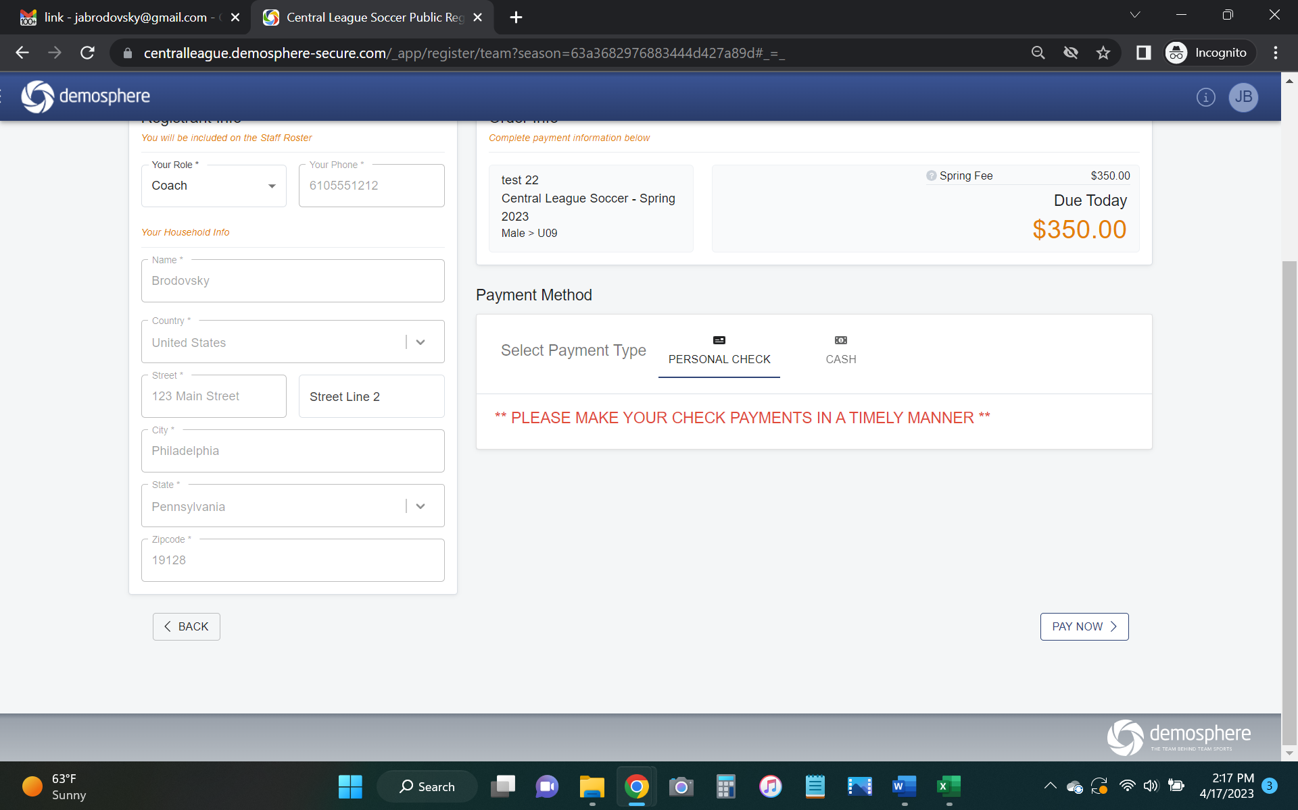
Then click on the Pay Now button
You should get the following Confirmation Message on your screen
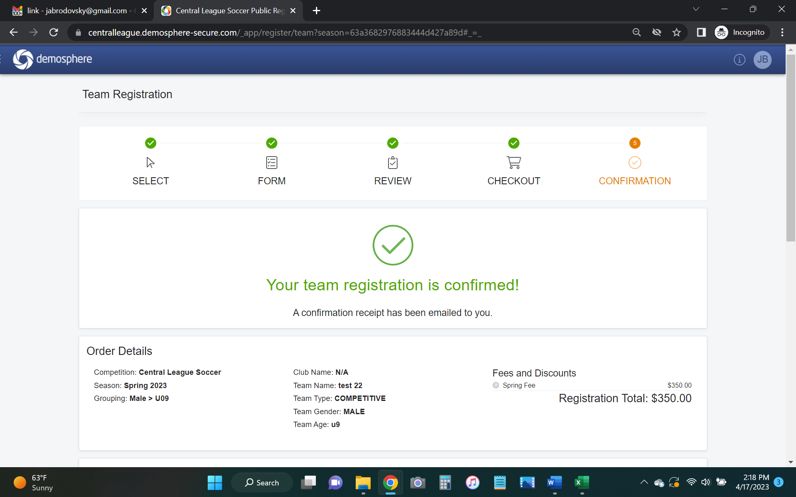
This will also be emailed to the address listed in the when the team was registered.
At this point, your team should be registered for the CLS season!

